Consumer goods industry of Bangladesh
What is consumer goods industry?
The consumer goods sector is a category of stocks and companies that relate to items purchased by individuals and households rather than by manufacturers and industries. These companies make and sell products that are intended for direct use by the buyers for their own use and enjoyment. This sector includes companies involved with food production, packaged goods, clothing, beverages, automobiles, and electronics.
Classification of consumer goods industry
Moving on to their classification: there are two types of consumer goods—durable goods and non-durable goods. While durable goods last, and buyers can use them over a long period, non-durable goods are consumed over a much shorter period.
Non-durable goods are better known as “fast-moving consumer goods” (FMCGs), or consumer-packaged goods (CPGs). FMCGs move off shop shelves faster than other goods, either because there is a huge demand for them or because they have a shorter shelf-life and deteriorate rapidly.
Examples of FMCG products are processed food and beverages, toiletries, cosmetics, household cleaning products, pet-care products, footwear, and over-the-counter drugs.
On the other hand, consumer durable goods usually have lifespans ranging from one to three years or more. Examples are electronic goods, kitchen appliances, and leisure equipment. They have a longer utility value than FMCG goods, and consumers require fewer repeat purchases of durables.
Potential of consumer goods industry in Bangladesh

Global Market
The global market size of the industry is expected to reach $1.54 trillion by 2025 With rising incomes, a growing middle-class and increasing rural-to-urban migration, it seems realistic to propose that companies operating within this industry will see rewarding pay-offs. Due to the nature of the consumer goods industry—characterized by low margins and high sales volumes—the industry is most likely to benefit from increasing its customer base, which will lead to greater sales. In this respect, Bangladesh represents a goldmine. Consumption expenditure clocked in at 97% of national income as of 2015 and with domestic annual consumption standing at over $130 billion, the growth of the internal economy has been accelerating.

Rapid Rural-to-Urban Immigration Drives Demand
As job opportunities are typically concentrated in the few urban centers of the country, the cities experience huge swathes of rural immigration. Consequently, most of the spending on FMCG products originate from these urban centers. With 35.70% of the nation’s population living in cities as of 2017, this number is only set to increase further and additionally bolster the industry in question.
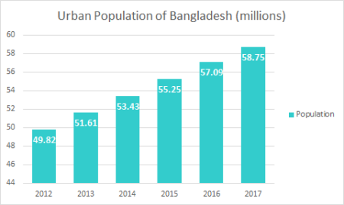

Rise of the Middle Class
Being beneficiaries of strong economic growth, Bangladesh is all set to attain Lower Middle Income Country status. According to the Boston Consulting Group, 2 million Bangladeshis are joining the ranks of the MAC every year. By the year 2025, the number of people belonging to MAC is expected to nearly triple to 34 million from 12 million in 2017. As the process unfurls, the FMCG industry should be able to capitalize on the situation.

Export Processing Zones (EPZ) Create Prosperity
There are 8 EPZs in Bangladesh. Among the aims of these EPZs are the diversification of the country’s exports and the creation of employment. As Bangladesh’s exports have risen, so has the importance of EPZs. Consequently, EPZs have created many jobs for women, which helps in poverty reduction . When incomes rise, one of the first categories of products to experience increasing demand are FMCG products. EPZs have played an important role in boosting the FMCG industry in Bangladesh.

Abundant Raw Materials and Cheap Labor
FMCG products in Bangladesh mainly include livestock, fruits, vegetables and other staples of the Bengali lifestyle. Due to its climate and geographic positioning, Bangladesh represents a gold mine of raw materials for companies in the FMCG industry. Cheap labor has additionally allowed the industry to grow further.

